Aim: To analyse and test a Progressive Web Application (PWA) using Google Lighthouse and evaluate its performance, accessibility, best practices, SEO, and PWA compliance.

Theory:

Q1. What is Google Lighthouse?
Google Lighthouse is an open-source, automated tool for improving the quality of web pages. It audits performance, accessibility, progressive web app (PWA) features, SEO, and more. You can run it in Chrome DevTools, from the command line, as a Node module, or via PageSpeed Insights.

Q2. What are the five categories evaluated by Lighthouse?
- Performance – Speed and visual stability (e.g., load time, interactivity).
- Accessibility – Ease of use for people with disabilities (e.g., screen reader compatibility).
- Best Practices – Follows web development standards (e.g., HTTPS, secure coding).
- SEO – Search engine optimization (e.g., meta tags, crawlability).
- Progressive Web App (PWA) – Capabilities like offline support and installability.

Q3. What is the purpose of Lighthouse in PWA testing?
Lighthouse provides an automated, standardized audit of PWA requirements. It checks if a web app meets the baseline criteria for being installable, reliable (offline/cache), and engaging (push notifications, splash screen). It helps developers identify missing PWA features before releasing to app stores or users.

Q4. What are the key PWA requirements checked by Lighthouse?
- Web app manifest – Proper manifest file with start_url, name, icons, display (e.g., standalone).
- Service worker – Registered and controls page on start.
- HTTPS – Site served over secure connection.
- Offline support – Returns 200 OK when offline (using service worker).
- Splash screen – Generated from manifest icons.
- Installable – Meets browser installability criteria (e.g., beforeinstallprompt fires).

Q5. What are performance metrics like FCP, LCP, and CLS?
- FCP (First Contentful Paint) – Time until the first piece of content (text/image) appears.
- LCP (Largest Contentful Paint) – Time until the largest visible element (hero image, heading) loads.
- CLS (Cumulative Layout Shift) – How much the page layout shifts unexpectedly while loading.

Q6. How does Lighthouse help improve web application performance and quality?
- Providing actionable reports – Scores (0–100) and specific recommendations (e.g., “reduce unused JavaScript”).
- Simulating real-world conditions – Throttles CPU/network to emulate slow devices/connections.
- Guiding PWA completeness – Ensures offline, installable, and fast experiences.
- Improving business metrics – Better performance leads to higher conversion, lower bounce rates, and better SEO.

Q7. To analyze a PWA using Google Lighthouse and observe the results.
Mobile Insights:
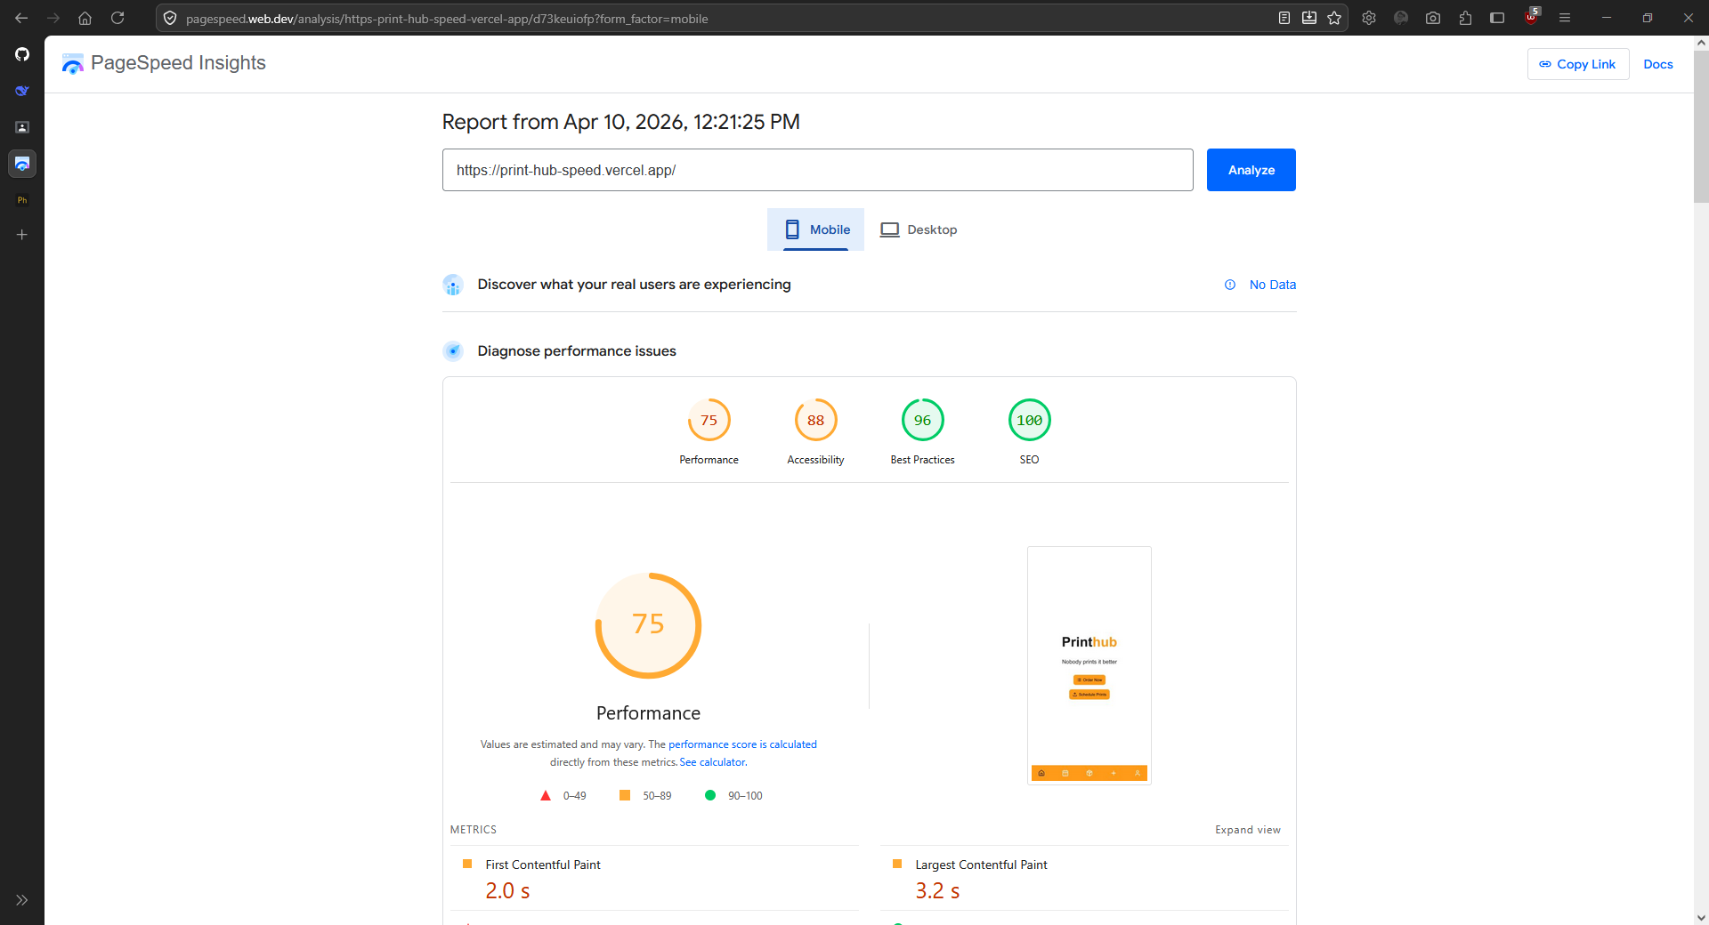

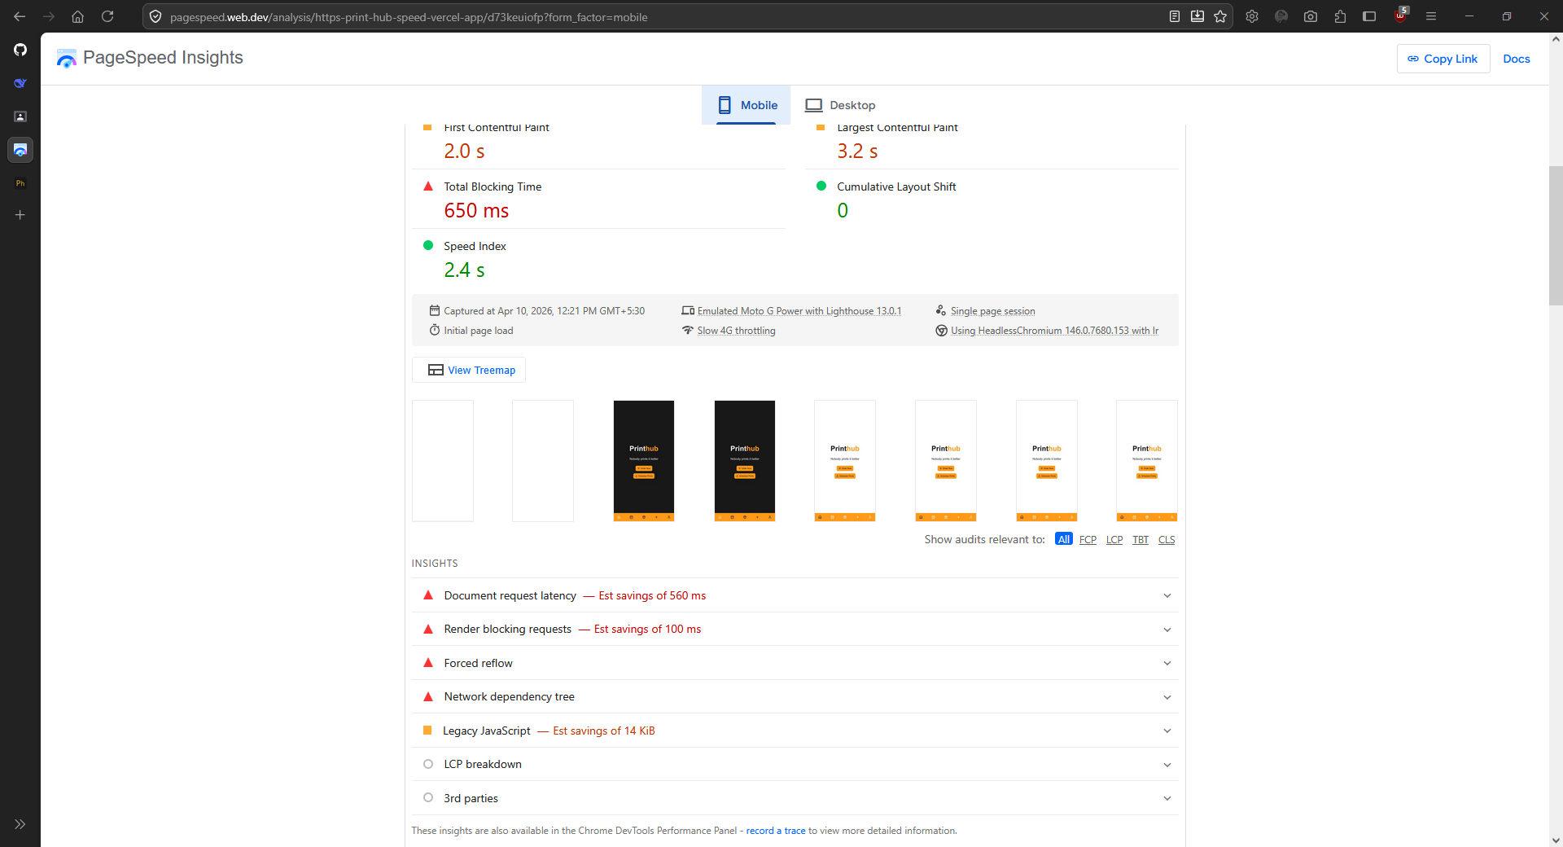
Desktop Insights:
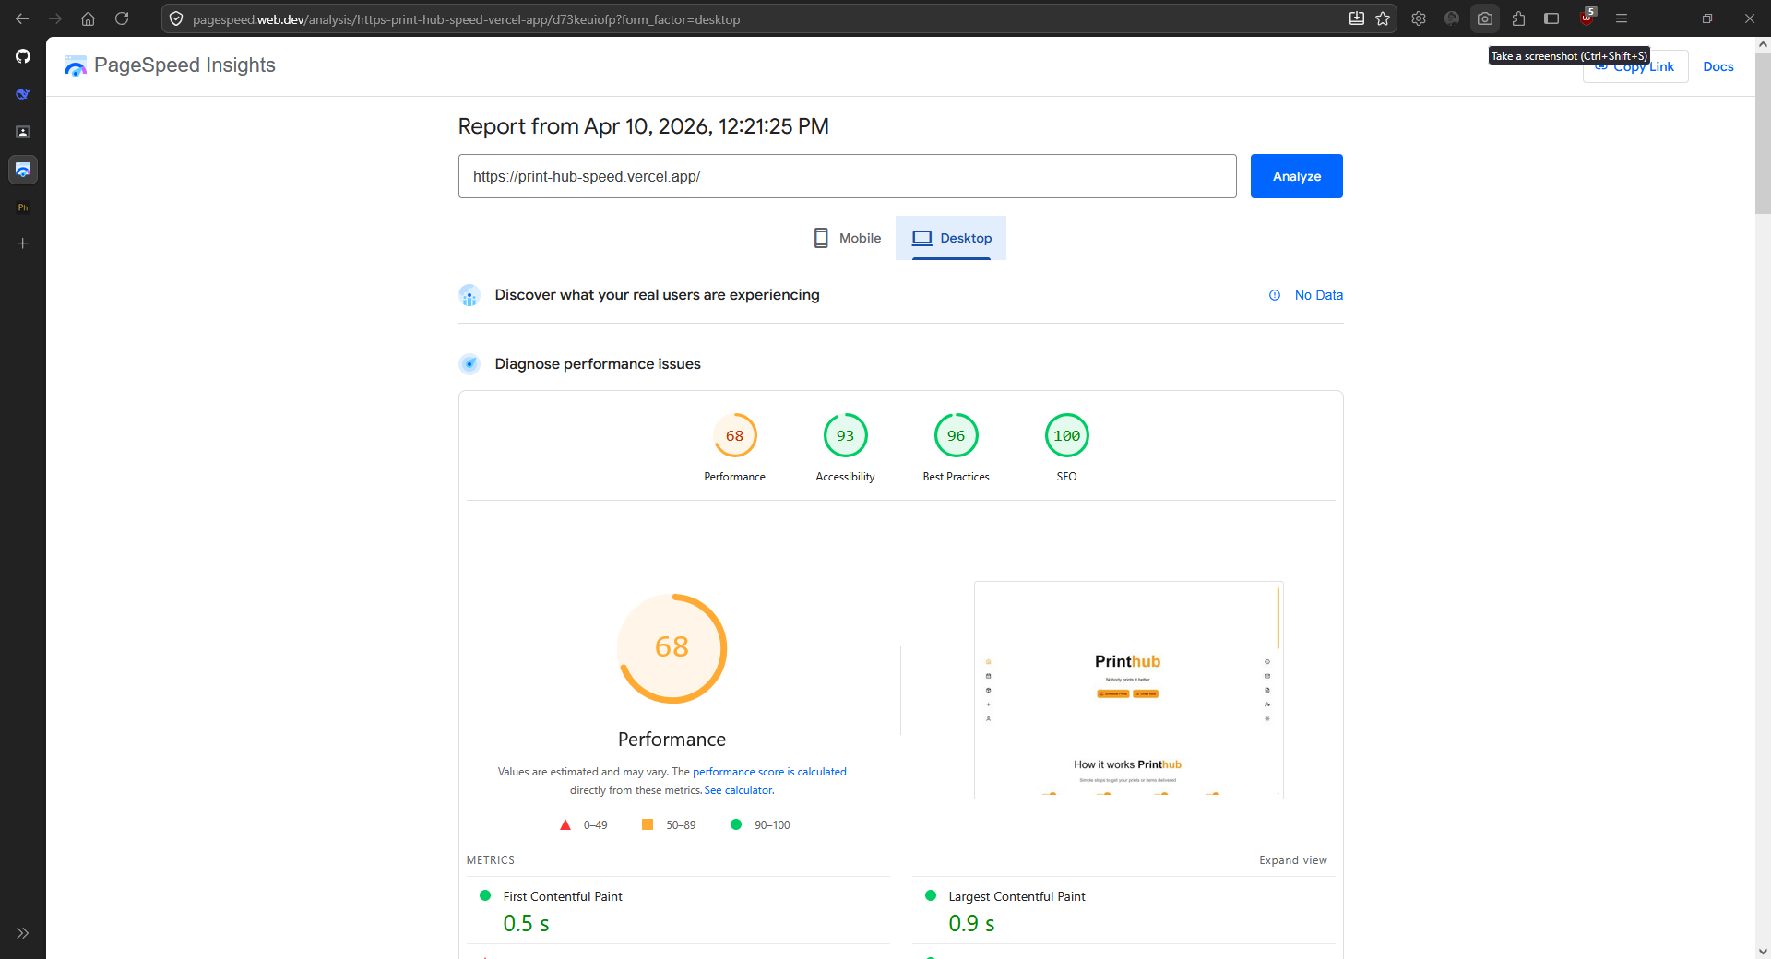

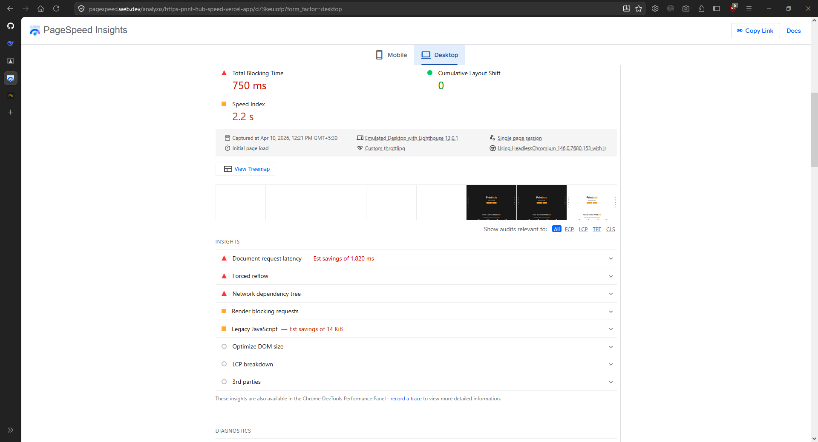

Conclusion
Successfully analysed and tested a Progressive Web Application (PWA) using Google Lighthouse and evaluate its performance, accessibility, best practices, SEO, and PWA compliance.

